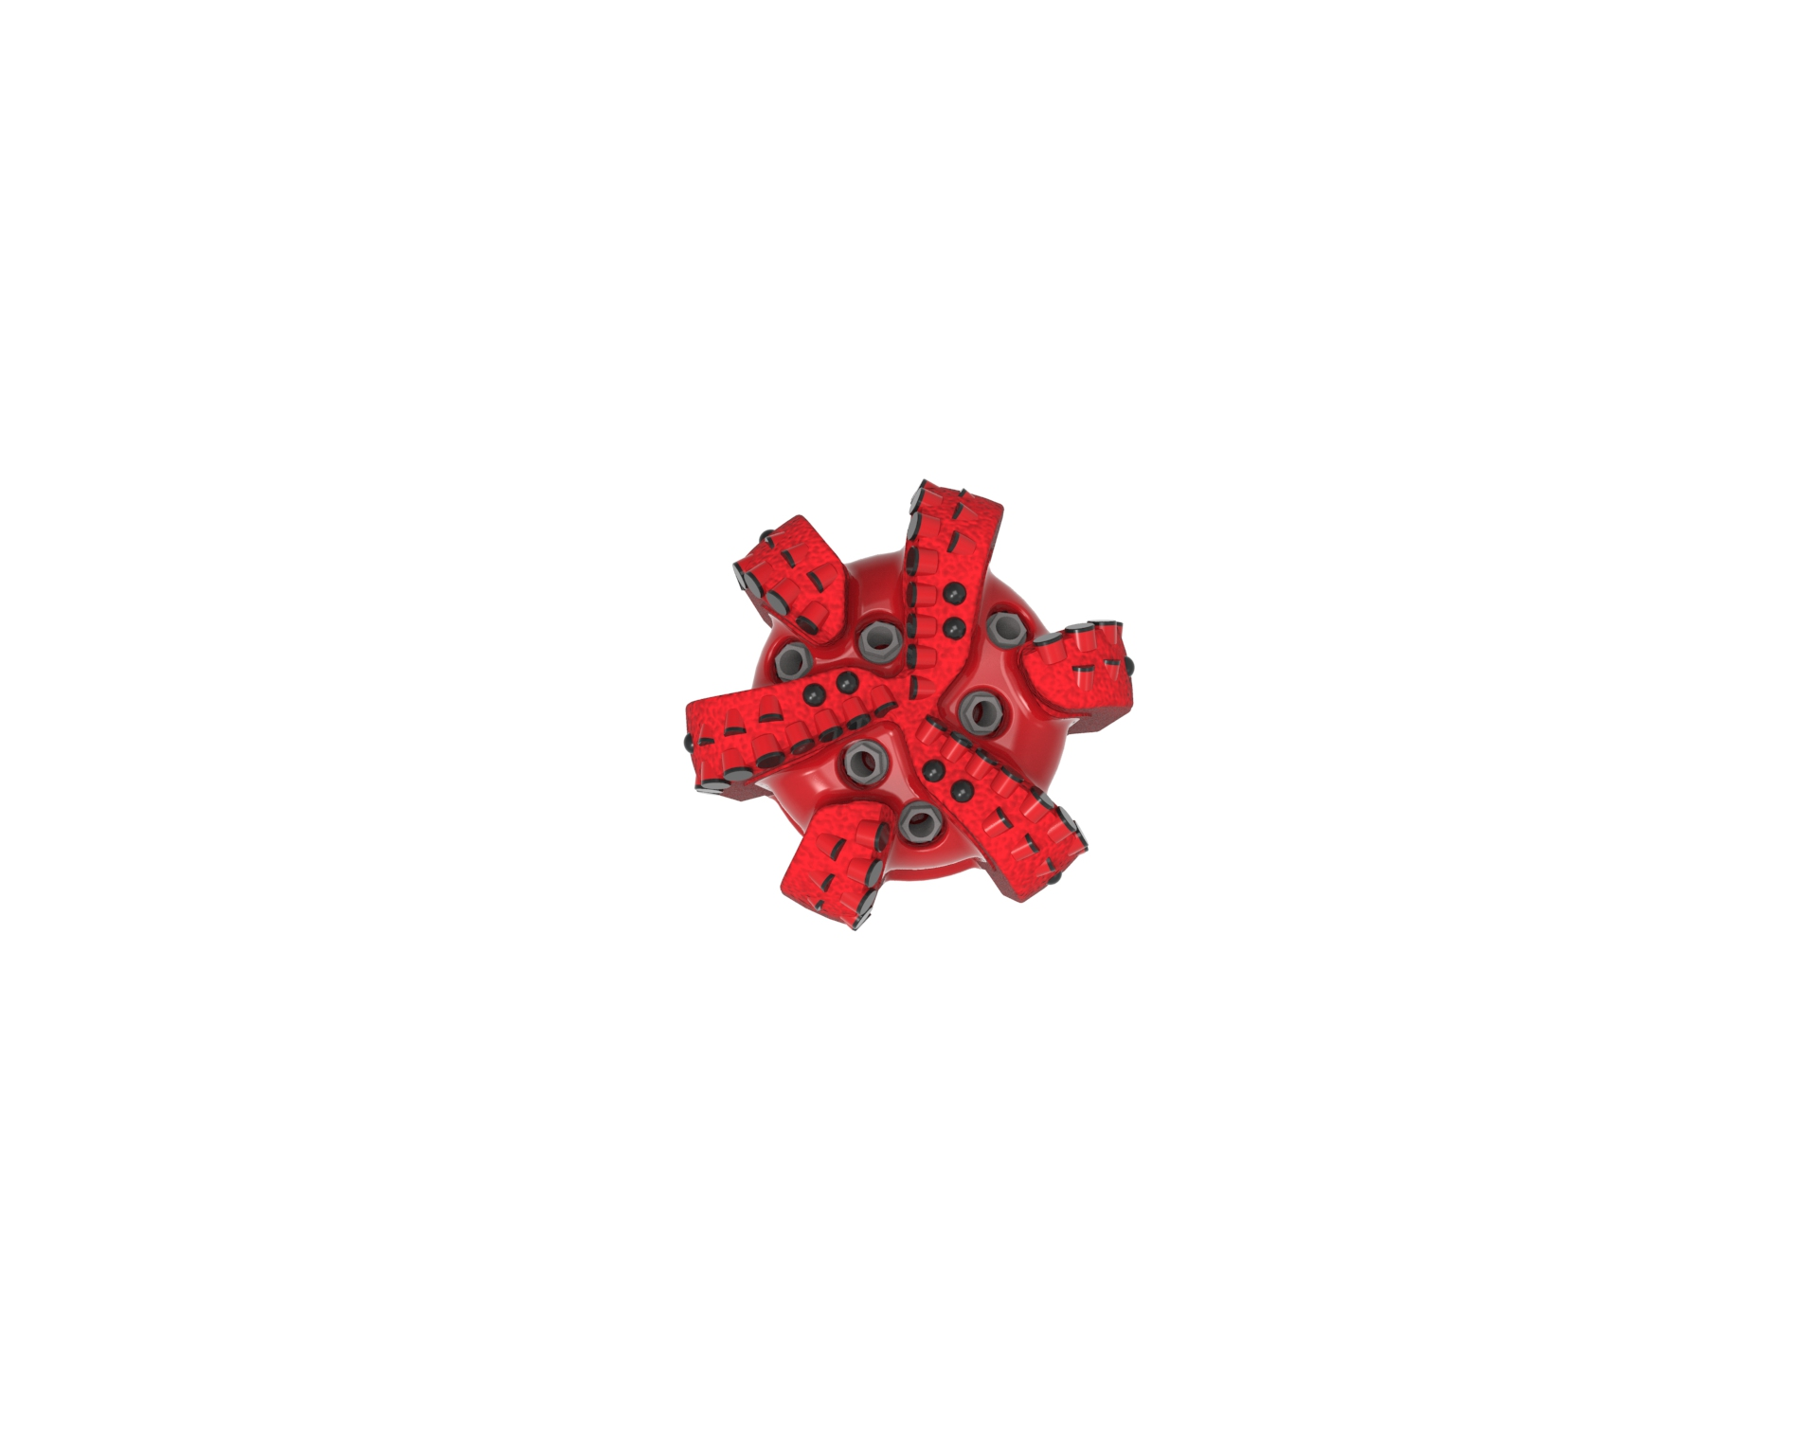
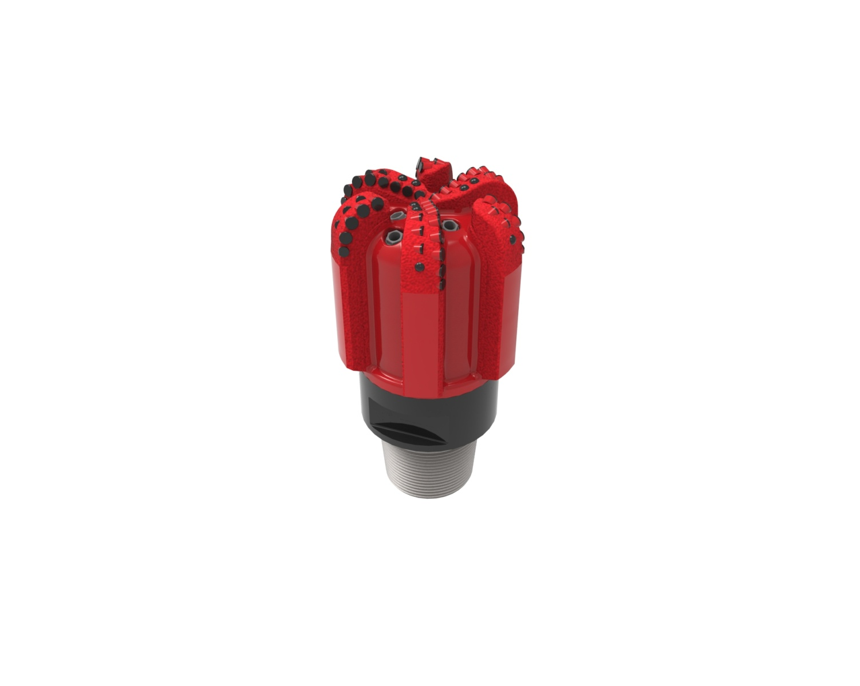

Drill Bit Specifications:
Cutter Size (Primary, Sec) | 5/8”,1/2”
Cutter Count (Total, Gage) | 60,6
Blade Count | 6
Gage Length (Inches) | 6.00
Nozzle Count (Primary, Sec.) | 6
Nozzle Series (Primary, Sec.) | 60
JSA (Sq. Inches) | 20.8
Max. TFA (Sq. Inches) | 2.23
Operating Parameters:
Max. Hydraulic Flow Rate (GPM) | 700
Max. Weight on Bit (1,000 Lbs.) | 40
Make-up Torque (ft/lbs) | 40,563
Nominal Dimensions:
Overall Length (Inches) | 18.75
Make Up Length (Inches) | 13.87
Bit Breaker | SKB-21011
Connection | Ø6-5/8" API Reg.
Approx. Weight (Lbs.) | 180

Standard Features:

- Large open face volume assists cuttings removal
- Six nozzles optimize blade cleaning and cuttings removal
- Premium grade cutters maximize ROP and Life

616-YR(K) Nomenclature Explained:

• | 6 | = | Number of blades
• | 16 | = | Primary Cutter Size (16mm)
• | YR+ | = | Offset Backup Cutters
• | K | = | Bullets


